BRIDGE GUARDRAIL CASE I B
DETERIORATED CURBS

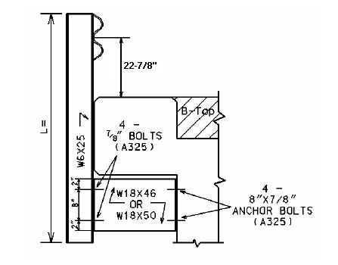
24-7/8”

Bridge MP | D = | W = | L = | No. Posts | LF of 2 PLY Rail

D = Curb Height W = Width of Bridge Curb L = Length of Guardrail Post

Warrants: Use Case I-B where the bridge curb is deteriorated and Case I or I-A cannot be used, and the bridge curb width is less than 12 Inches.

NOTES:

- When Case I-B Guardrail is used, use a Precast Concrete Bridge Block at the ends of the bridge which face opposing traffic. See detail drawing for Precast Concrete Bridge Block.

- If concrete bridge rail needs to be removed from the bridge, include a bid item for Remove Concrete Masonry.

